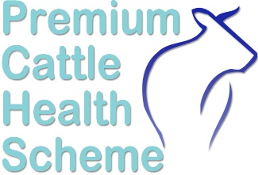
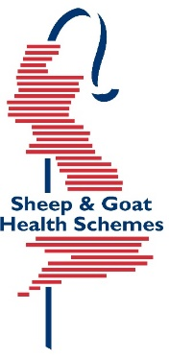
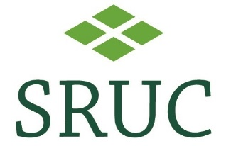
T
Health Schemes Application Form
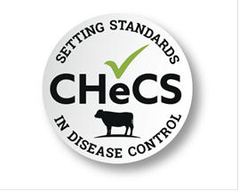
Please return completed form to:
SRUC Veterinary Services, Greycrook, St Boswells, TD6 0EQ
Phone: 01835 822456 Email: healthschemes@sruc.ac.uk

Which Scheme(s) do you wish to join:
Scheme (tick as required)
Premium Cattle Health Scheme (PCHS) Includes BVD/IBR/Lepto/Johne’s/Neospora
Premium Cattle Health Scheme (PCHS) BVD ONLY
DAIRY BVD NEGATIVE ONLY
Premium Sheep and Goat Health Scheme (PSGHS) Accreditation Scheme
Premium Sheep and Goat Health Scheme (PSGHS) Monitoring Scheme

Please note we have a separate application form for joining the TB scheme, this can be found on our website.
Owner Details & Contact:
Title
Forename(s)
Surname
Trading Name (if applicable)
Correspondence Address
County
Postcode
Mobile |  | Landline
Holding Number (CPH)
Email (results will be sent
to this address)

Veterinary Practice:
Practice Name
Address
Postcode

All work is undertaken in accordance with SRUC Vet Services’ Sample Policy, Terms and Conditions and GDPR found on our website at www.sruc.ac.uk/vets
SRUC Innovation Limited. A subsidiary company of SRUC. Registered in Scotland, Company Number SC148684
Breed(s) – main 3 only:
Please complete this page if you are applying for PCHS membership

Premium Cattle Health Scheme
Address Cattle kept at:
Same as correspondence | Yes / No (delete as appropriate)
Address
Postcode

Breed(s) – main 3 only:

Herd Prefix (UK number):

Do you intend to keep accredited and non-accredited animals on the holding? | YES / NO

If YES, please provide details …………………………………………………………………………………….
…………………………………………………………………………………………………………………………
………………………………………………………………………………………………………………………….

Please let us know how you heard about the Health Scheme(s) and what prompted you to join?
…………………………………………………………………………………………………………….
If you are transferring from another Health Scheme, please let us know which scheme so we can get copies of your records:
Name of Scheme: ………………………………………………………………………………………

IMPORTANT: Please see the Declaration & Authorisation page at the end of this form regarding how we obtain your animal details from BCMS/ScotEID
All work is undertaken in accordance with SRUC Vet Services’ Sample Policy, Terms and Conditions and GDPR found on our website at www.sruc.ac.uk/vets
SRUC Innovation Limited. A subsidiary company of SRUC. Registered in Scotland, Company Number SC148684
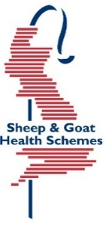
Premium Sheep & Goat Health Scheme
Do you wish to join the Accreditation Scheme OR the Monitoring Scheme
SCHEMES TO JOIN (please tick as appropriate) | Accreditation | Monitoring
Maedi Visna (MV) for sheep
Caprine Arthritis Encephalitis (CAE) for goats
EAE (not available in the Monitoring Scheme)
Johne’s disease for sheep/goats

Same as correspondence | Yes / No (delete as appropriate)
Address
 |  | Post Code

Address Sheep/Goats kept at:

Breed(s) to be included in the scheme:

Sheep
Goats

 | CURRENT STOCK – ANIMALS JOINING PSGHS
 | SHEEP |  | GOATS
 | Female | Male | Female | Male
< 12
months
12-17
months
18months
and over

Flock/herd Name

Flock/herd Number

Are you joining with MV/CAE Accredited stock? | YES | NO
If so, date 1st accredited animal arrived on farm | date

To complete for Accreditation Scheme only

Please note if you are starting with accredited stock, you must complete a Premises Check Form. Purchased Accredited stock must be tested 6 – 12 months post purchase to maintain their status.

All work is undertaken in accordance with SRUC Vet Services’ Sample Policy, Terms and Conditions and GDPR found on our website at www.sruc.ac.uk/vets
SRUC Innovation Limited. A subsidiary company of SRUC. Registered in Scotland, Company Number SC148684
Do you have any stock which are to remain NON-Accredited? YES / NO

IMPORTANT – Premium Cattle Health Scheme (PCHS)
For English and Welsh holdings, we use the British Cattle Movement Service (BCMS) data and for Scottish holdings we use ScotMoves+ (ScotEID) data to produce specific barcoded labels for sample testing. We have been granted “Agent Access” where once we have your permission, we can access a list of the cattle on your farm. This is a one-off procedure and as our access is ‘read only’, your data is secure.
Please contact the office on 01835 822456 or email healthschemes@sruc.ac.uk to request a copy of instructions on how to add PCHS as one of your agents.
WE CANNOT PRODUCE LABELS FOR ANNUAL TESTING WITHOUT THIS ACCESS
Labels are only provided for annual screens. For any other testing, please use our Premium Cattle Health Scheme submission form.
Declaration & Authorisation

All work is undertaken in accordance with SRUC Vet Services’ Sample Policy, Terms and Conditions and GDPR found on our website at www.sruc.ac.uk/vets
SRUC Innovation Limited. A subsidiary company of SRUC. Registered in Scotland, Company Number SC148684
Premium Health Schemes has an online list of Health Scheme members which displays their name, address, contact details and current herd/flock status.
If you DO NOT wish for your details to be displayed online, please tick here:

Name (print): …………………………………………………………………………………………

Signature: ………………………………………………………………. Date: ……………………
I wish to apply for membership of the Premium Health Scheme.
I certify that the details given on this form are, to the best of my knowledge, correct.
I agree for all relevant information to be shared with my veterinary surgeon.
I agree to adhere with the Scheme rules.
I agree that SRUC can randomly inspect my flock/herd at any time to check rules are being adhered to. This may be carried out by SRUC or subcontracted.
I agree to pay all fees payable under the Premium Health Scheme and understand that failure to do so may result in the suspension or withdrawal of my membership.

