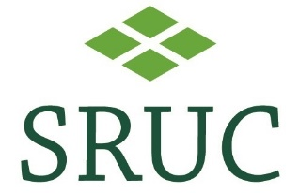

PREMIUM CATTLE HEALTH SCHEME BVD CALF SCREEN DECLARATION
For tissue tags tested outwith SRUC Veterinary Services

Member Number:

All calves born ………………………………………………………………………………………. have been tested for BVD virus with negative results.
Herds outwith Scotland: Please include a copy of all results with this form.
To use these results for PCHS BVD Accreditation, there will be an administration fee (currently £80)

CHECS BVD Programme Mandatory Elements | Yes/No
Herd definition – are all cattle on the holding in the accredited herd?
If not, a description of herd management is required to document how the biosecurity rules of the scheme are met.
Double fencing or use of an equivalent boundary to provide gap of 3 metres between scheme cattle and any neighbouring cattle is in place.
Mandatory for BVD accredited free, optional for BVD VMF herds.
Is the breeding herd vaccinated against BVD?
Optional for BVD accredited free, mandatory for BVD VMF herds.
Are suitable quarantine facilities available?
Have all added and returning animals been isolated and tested appropriately?
Feed, bedding and water supplies - what methods are employed to prevent the spread of disease through these sources?
(Continued overleaf)
Equipment and visitor - what methods are employed to prevent the spread of disease through these sources?
Has there been any abortion, or clinical disease where BVD was suspected?
All testing or disease over the last 12 months relevant to accredited diseases must be documented and reviewed.

OWNER/MANAGER - I agree to abide by the Rules and Conditions of membership and confirm that they have been followed for the period covered by this declaration. All information is correct as at the time of recording.

Signed ……………………………………………………………………………..…………. Owner/Manager
Name (block letters) ………………………………….………….…………… Date …………….……….
Holding Number (CPH) ……………………………….………. Post Code ………….……………………
VETERINARY SURGEON - I have explained the rules of the Scheme to my client who, to the best of my knowledge, is complying with the Rules and Conditions of the PCHS. To the best of my knowledge the above information provided by the farmer is correct.

Signed ………………………………………………………………………………………………...... MRCVS/FRCVS
Name (block letters) ……………………………….………………………………… Date ……………..……….
Declaration by Owner and Veterinary Surgeon:

