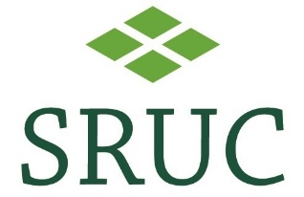
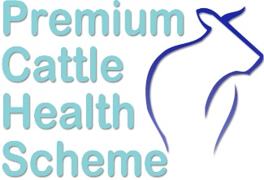
T
Health Schemes Application TRANSFERRING FROM BIOBEST

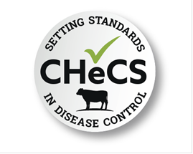
Please return completed form to:
SRUC Veterinary Services, Greycrook, St Boswells, TD6 0EQ
Phone: 01835 822456 Email: healthschemes@sruc.ac.uk

Tick here to allow Biobest to transfer your testing history to PCHS

Please tick below the diseases you are currently Accredited/Testing for:
DISEASE | ACCREDITED FOR | TESTING FOR
BVD
Johnes
IBR
Lepto
Neospora
bTB Accreditation
Title
Forename(s)
Surname
Trading Name (if applicable)
Correspondence Address
County
Postcode
Mobile |  | Landline
Holding Number (CPH)

Any additional CPH
Email (results will be sent
to this address)

Please note we have a separate application form for joining the TB scheme, this can be found on our website.

Veterinary Practice:
Practice Name
Address
Postcode

HERD DETAILS
HERD UK PREFIX:  Eg UK123456 | UK
ACCREDITED BREEDS:

Please tick here if you DO NOT wish for your herd details and status to appear on our online Members Database:

Our database displays Name, Address, Phone Number, Breed and current Herd Status.
Is your herd a Dairy herd? |  | YES | NO
Do you intend to keep Accredited and Non-Accredited animals on the holding? |  | YES | NO
IMPORTANT:
For English and Welsh holdings, we use British Cattle Movement Service (BCMS) data and for Scottish holdings we use ScotMoves+ (ScotEID) data to produce specific barcoded labels for sample testing.
We require you to grant us with “Agent Access”. Once we have your permission, we can access a list of the cattle on your farm. This is a one-off procedure and as our access is ‘read only’, your data is secure. The relevant instructions have been attached.
WE CANNOT PRODUCE LABELS FOR ANNUAL TESTING WITHOUT THIS ACCESS Labels are only provided for annual screens. For any other testing, please use our Premium Cattle Health Scheme submission form found on our website.

DECLARATION
I wish to apply for membership of the Premium Health Scheme.

I certify that the details given on this form are, to the best of my knowledge, correct.

I agree for all relevant information to be shared with my veterinary surgeon.

I agree to adhere with the Scheme rules.

I agree that SRUC can randomly inspect my herd at any time to check rules are being adhered to. This may be carried out by SRUC or subcontracted.

I agree to pay all fees payable under the Premium Cattle Health Scheme and understand that failure to do so may result in the suspension or withdrawal of my membership.

NAME (PRINT)
SIGNATURE |  | DATE:
All work is undertaken in accordance with SRUC Vet Services’ Sample Policy, Terms and Conditions and GDPR found on our website at www.sruc.ac.uk/vets
SRUC Innovation Limited. A subsidiary company of SRUC. Registered in Scotland, Company Number SC148684
All work is undertaken in accordance with SRUC Vet Services’ Sample Policy, Terms and Conditions and GDPR found on our website at www.sruc.ac.uk/vets
SRUC Innovation Limited. A subsidiary company of SRUC. Registered in Scotland, Company Number SC148684

