Blog Planting for pollinators article

Five years ago, Annan Academy Bee Club discovered their bees had a fungal disease called Nosema and wanted to find a way to help their bees survive. They decided to test their honey to see what their bees were foraging (or feeding) on. They then researched plants that were good for bee health that were not found in their honey, for example borage, phacelia, wildflowers, white clover, herbs, and lavender. They then bought plants and seeds and gave them away to local schools, groups, and the wider community at local events. One year later they tested their honey again and not only found these new pollens in their honey but that the bees had also brought in other medicinal pollens. Bees would normally dwindle and die with Nosema, but due to their improved nutrition, bees were stronger and when tested again appeared to have a lower level of infection. This suggested planting for pollinators helped the bee health.
Planting for bees
Bees need a mixture of pollen and nectar which gives them a source of protein and carbohydrate. They feed on a variety of plants, trees, shrubs, hedges, and wildflowers.
- They need food all year round so in winter they will forage on snowdrops, bluebells, aconites, and hellebores.
- In spring they will forage on gorse, dandelion, red current, willow, sycamore, and hawthorn. These provide a variety of pollen, which the bees need in the same way that we need a variety of fruit and vegetables to be healthy.
- In summer they will collect pollen and nectar from many different herbs, clover, blackberry, knapweed, rosebay willow herb, honeysuckle, and asters. Some of the older readers may remember sucking the nectar from clover plants and the smell of a field of clover is stunning.
- In autumn they feed on ivy, heather, mahonia, abelia and wallflowers. It is important for bees to get enough food in autumn to get them through winter. If they do not have enough, beekeepers will feed them with a sugar syrup mixture to keep them going.

There have been a couple of instances where I have been called out to collect swarms of honey bees, but when I have got there, they were not swarms but bees gathering around sources of food they love. The first time I was called to a cotoneaster plant. Bees love this plant and the bush was buzzing with bees having a food fest. The key to knowing the difference was they were not clustered in a ball and they left before it got dark to go home. The second was an ivy tree in flower. I knew it would not be a swarm in late October, but I went along as it was near a local school. It was an incredible sight. Not only honeybees but wasps, flies, and many other pollinators all on the same tree. Anyone interested in insect spotting should certainly observe ivy in flower.

My favourite bee plants trees, shrubs, and hedges
I did not know much about plants and flowers before I started beekeeping but one of my mentors Janet introduced me to the poached egg plant. It is not only beautiful but can be great as ground cover or in a planter, and the bees love it. I love to hear the bees buzzing on a willow tree and bees feeding in my small herb garden with thyme, rosemary, chives, and lemon balm. Although it is not what I would call beautiful, gorse provides pollen when there is sometimes a lack of other plants in bloom. Like many of you I love collecting berries from hedges. Berry numbers would be much depleted without the bees.

Benefits of bees to farmers
Fruit producers use bees to increase their yields and in fields of Oil Seed Rape. They have proven an increase in yields of between 15-40%. Pollination contracts south of the border can sometimes mean an extra income for beekeepers. Bees pollinate over a third of our food, so it is important we keep planting to ensure our food security and the sustainability of bees.
I am on the list of advisors for the biodiversity, sustainability and land management grant offered by SRUC. If you have any further questions or need advice on any of this, please do get in touch.

SRUC are holding a Power for Pollinators event at the Barony campus on the 27th of February which is free for smallholders, farmers, crofters, and beekeepers. There will be information stalls hosted by groups such as the Scottish Beekeepers, SRUC, South West Scotland Environmental Information Centre (SWSEIC) and more. There will also be three talks, on bees and Oil Seed Rape, the Yellow Legged Hornet, and plants for pollinators. If you are interested, please do email me and I will send you booking details.
Lorraine.Johnston@sruc.ac.uk
Honey bee in a poached egg plant
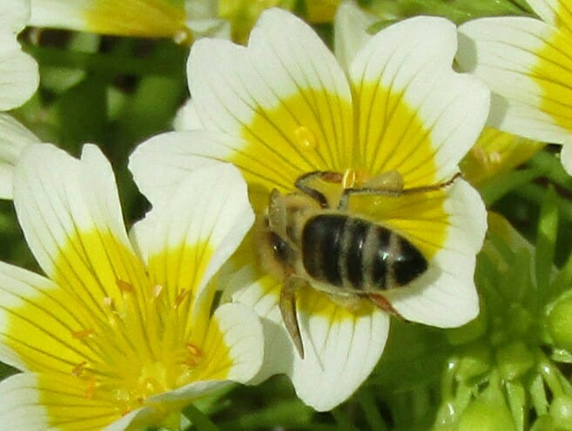
Honey bee on a crocus
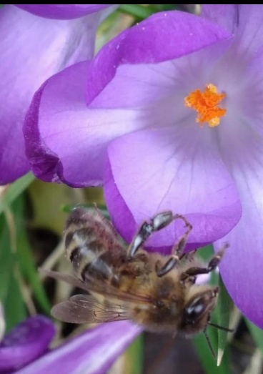
Dandelion pollen under a microscope
